Barriers, Entrapment, and Electrical Safety
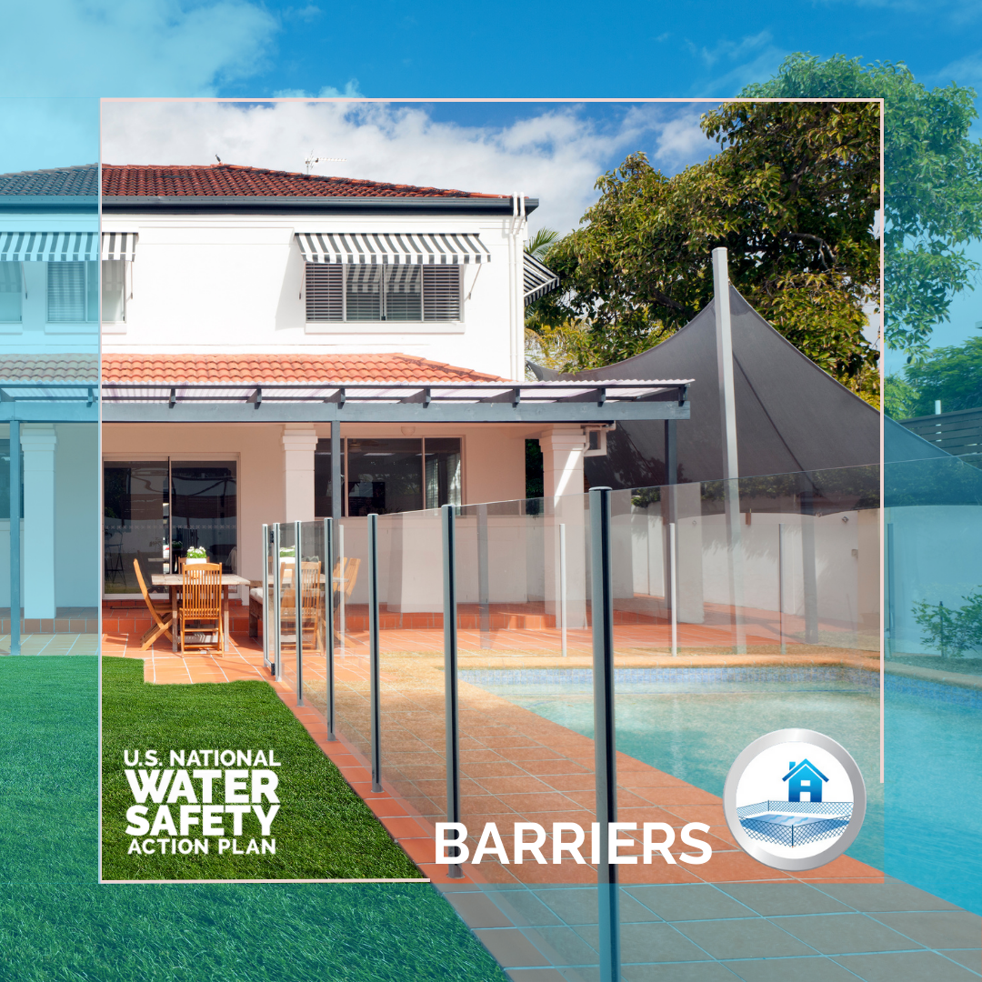
In the blink of an eye a child can fall into a pool, unnoticed by others around them. Did you know that hundreds of children could be saved from drowning each year if residential pools have appropriate fencing?
As part of the U.S. National Water Safety Action Plan (@usnwsap), we are recommending 17 tactics to governments, educators, aquatics operators, and everyday changemakers to prevent injury or death by entrapment, electrocution, and absence of barriers, including:
- Requiring the use of four-sided isolation fencing with self-closing and self-latching gates around residential pools and spas
- Requiring that new and existing residential pools and spas are aligned with the Virginia Graeme Baker Pool and Spa Safety Act (VGBA) that public pools follow.
- Recommending an alarm system as an adjunct layer of protection for residential and semi-private pools and spas
Head to watersafetyplan.us for more #USNWSAP recommendations and to learn how we’re working to stop drownings nationwide.
[Insert your organization's name] is proud to partner with [insert other handles] on the #USNWSAP to lead a coordinated effort to prevent drowning nationwide.

Data and Public Health Surveillance
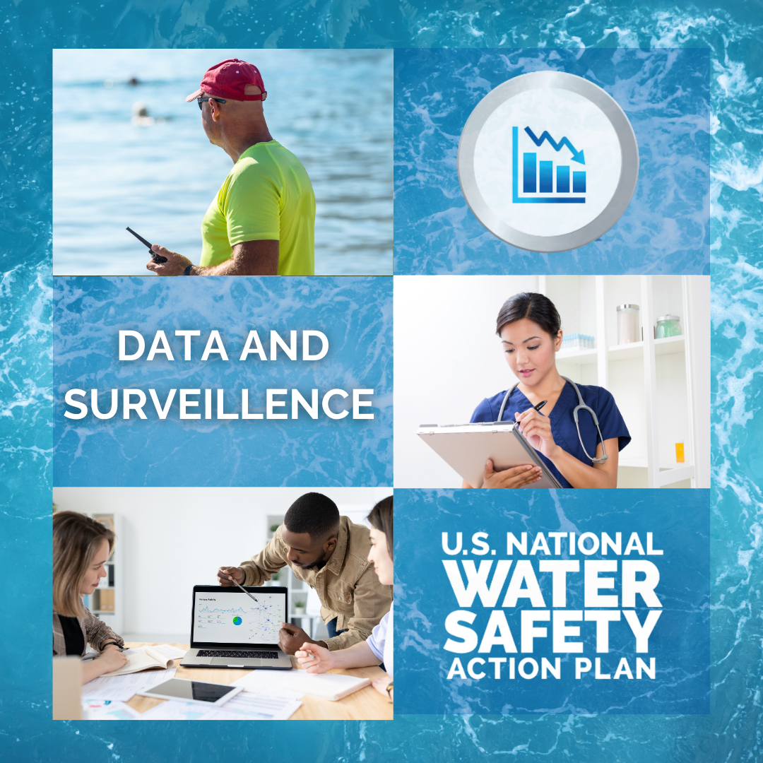
The world is more connected than ever, so why is data on drowning so hard to find?
Launched in June, the U.S. National Water Safety Action Plan (@usnwsap) has recommended 18 tactics to minimize the mystery of how people drown—including launching a singular nationwide reporting system.
Together, let’s use comprehensive data to inform #drowningprevention, better understand at-risk groups, and save lives.
Visit watersafetyplan.us to learn how #USNWSAP is making everyone in the U.S. safer around water.
[Insert your organization's name] is proud to partner with [insert other handles] on the #USNWSAP to lead a coordinated effort to prevent drowning nationwide.

Life Jackets, Personal Flotation Devices, and Other Flotations
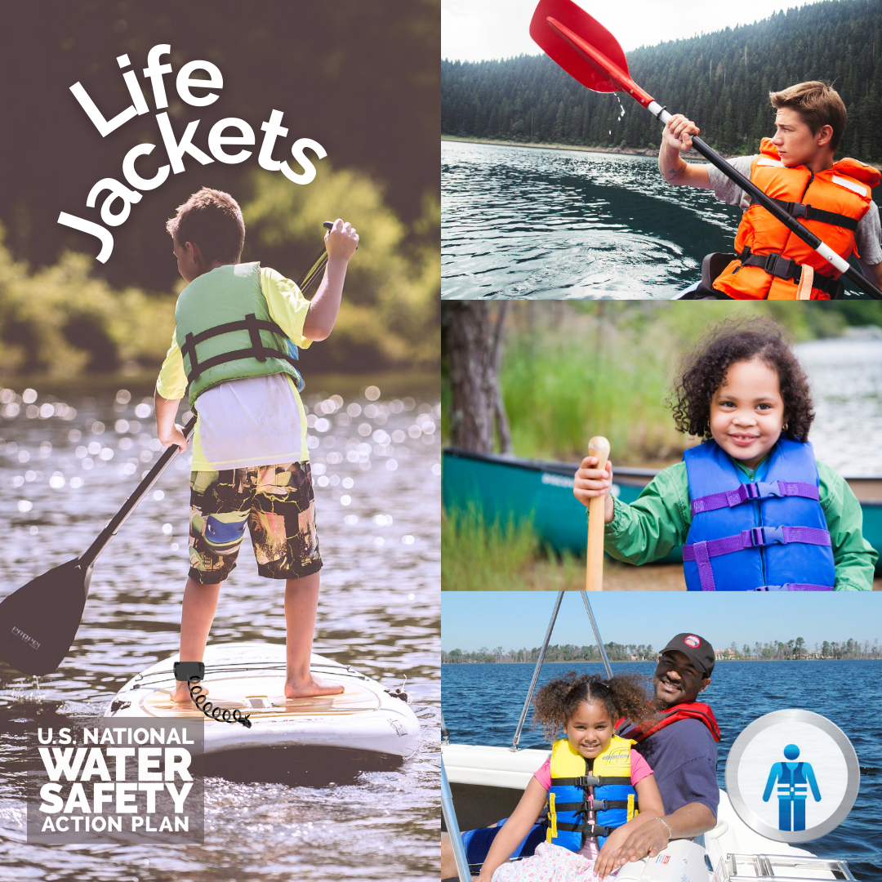
When it comes to saving lives in water, few tools work better than a U.S. Coast Guard–approved life jacket. Yet, guidance around who should wear a life vest, and when, varies by region.
The brand-new U.S. National Water Safety Action Plan (@usnwsap) has created 21 safety suggestions to take the guesswork out of life jacket protocol, and we’re encouraging governmental and educational leaders across the country to adopt these centralized guidelines to save lives.
Learn about #USNWSAP and review our personal flotation device action items at watersafetyplan.us
[Insert your organization's name] is proud to partner with [insert other handles] on the #USNWSAP to lead a coordinated effort to prevent drowning nationwide.

CPR and Rescue
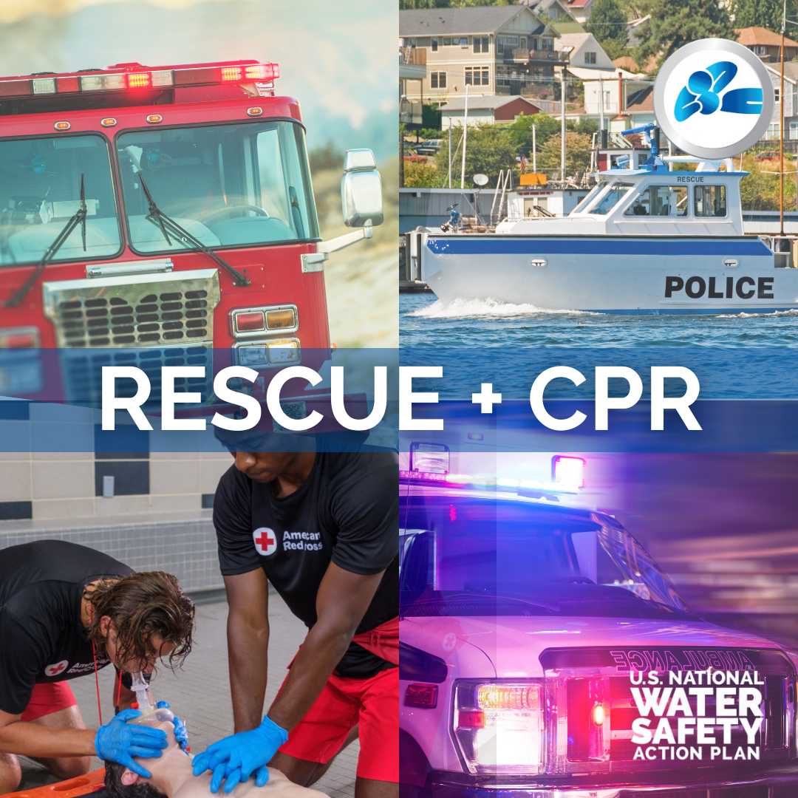
Did you know that in the U.S. there isn’t a centralized means for diverse professional agencies to share best practices for water rescue? Let’s change that.
The U.S. National Water Safety Action Plan (@usnwsap) puts forward 15 action recommendations to improve water rescue protocols and training in our country. Learn more at watersafetyplan.us
[Insert your organization's name] is proud to partner with [insert other handles] on the #USNWSAP to lead a coordinated effort to prevent drowning nationwide.

Lifeguards and Supervision
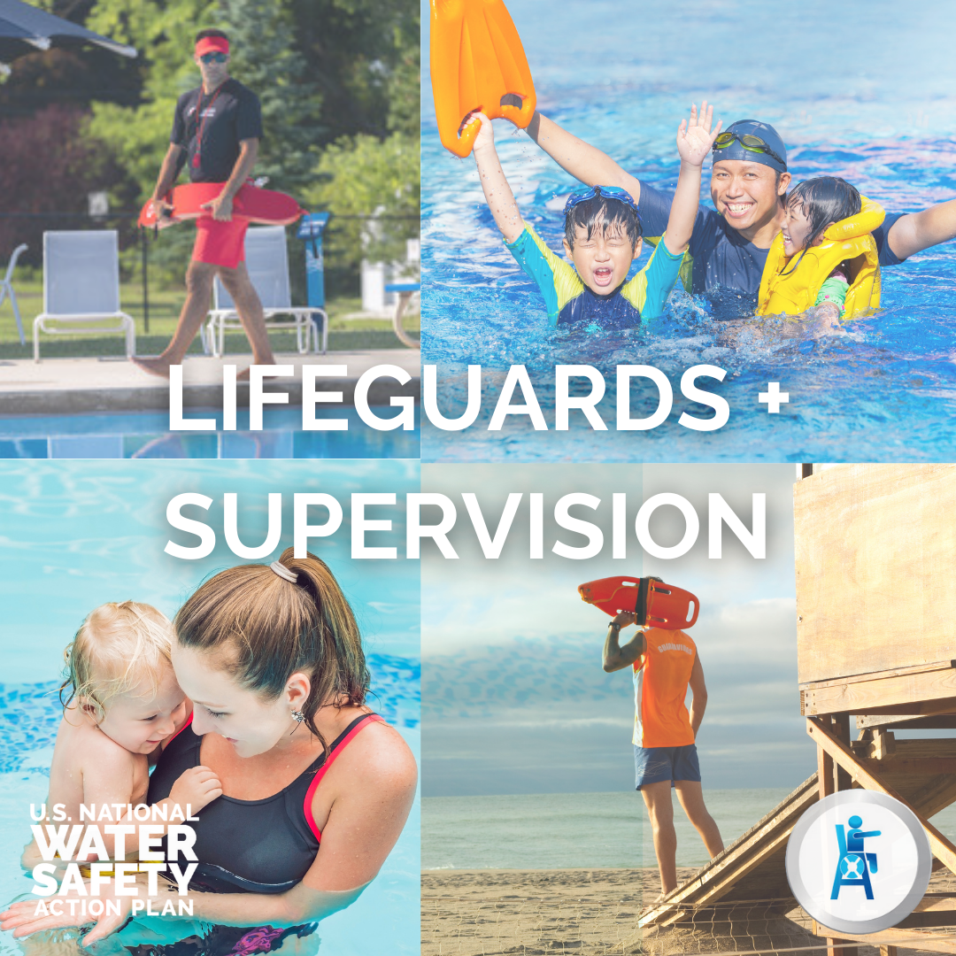
Swimming where trained lifeguards are on duty reduces the risk of drowning. Are you aware of other layers of protection, including adult supervision by a trained water watcher, that reduce drowning risks for the numerous swimming locations that are not monitored by trained lifeguards?
The U.S. National Water Safety Action Plan (@usnwsap) presents 9 action recommendations to ensure lifeguards and chaperones have the necessary resources and qualifications to prevent and respond in a water rescue. Encourage your representatives and local aquatic operators to review the #USNWSAP at watersafetyplan.us and implement these life-saving steps.
[Insert your organization's name] is proud to partner with [insert other handles] on the #USNWSAP to lead a coordinated effort to prevent drowning nationwide.

Water Safety, Water Competency, and Swimming Lessons
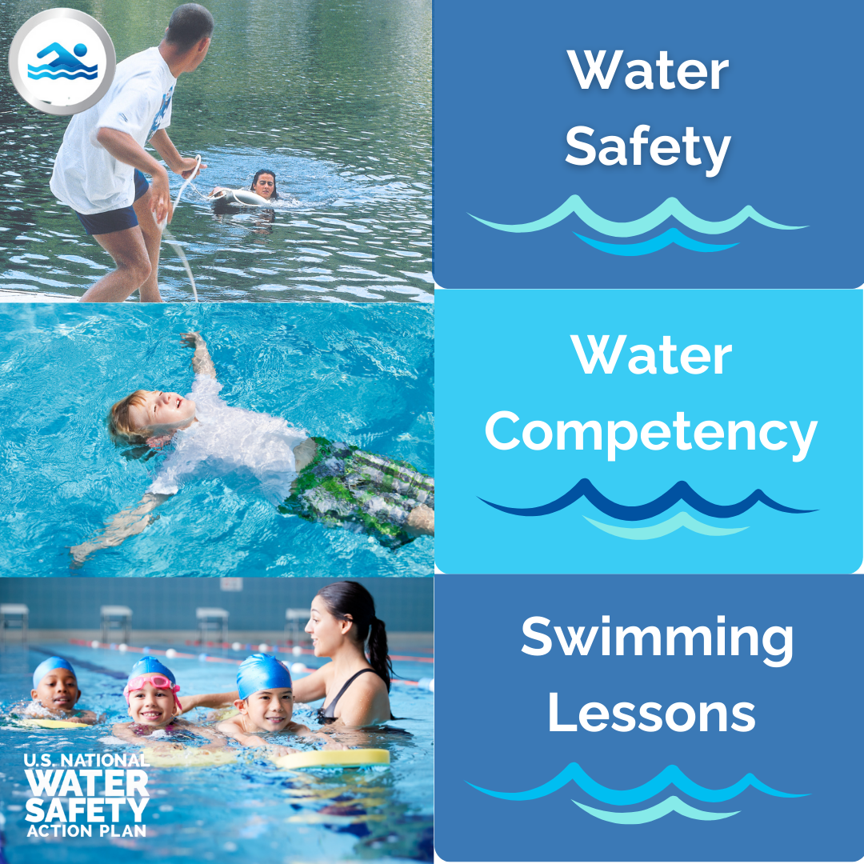
Being water competent saves lives. Yet many Americans—due to geographic, economic, or other barriers—never learn how to swim, let alone survive, in the water. Many others underestimate their ability, or that of their children, to be safe in deep water. It may take multiple swim lessons to impart the necessary water competency skills and knowledge.
As part of the U.S. National Water Safety Action Plan (@usnwsap), we are recommending 18 urgent action items around water safety education, urging federal, state, and local changemakers to improve access to water safety for their constituencies and communities.
Visit watersafetyplan.us to learn more about the #USNWSAP.
[Insert your organization's name] is proud to partner with [insert other handles] on the #USNWSAP to lead a coordinated effort to prevent drowning nationwide.

